SUMMER TRAINING REPORT
ON
TODO LIST APPLICATION
Submitted to Guru Gobind Singh Indraprastha University, Delhi (India) In partial fulfilment of requirement for the award of the degree of

BACHELOR OF TECHNOLOGY
in
COMPUTER SCIENCE AND ENGINERING
at
DELHI TECHNICAL CAMPUS, GREATER NOIDA
SUBMITTED BY
Adityan Verma
07818002721
SEC – ‘B’
2023-24
SUBMITTED TO
Ms. Rashmi
(Assistant Professor)

Department of Computer Science & Engineering
SESSION 2023
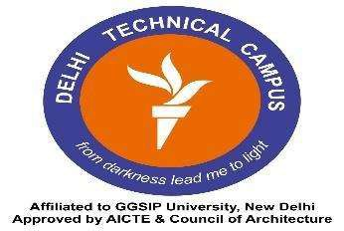

DELHI TECHNICAL CAMPUS, GREATER NOIDA
(Affiliated by Guru Gobind Singh Indraprastha University, New Delhi)

CERTIFICATE

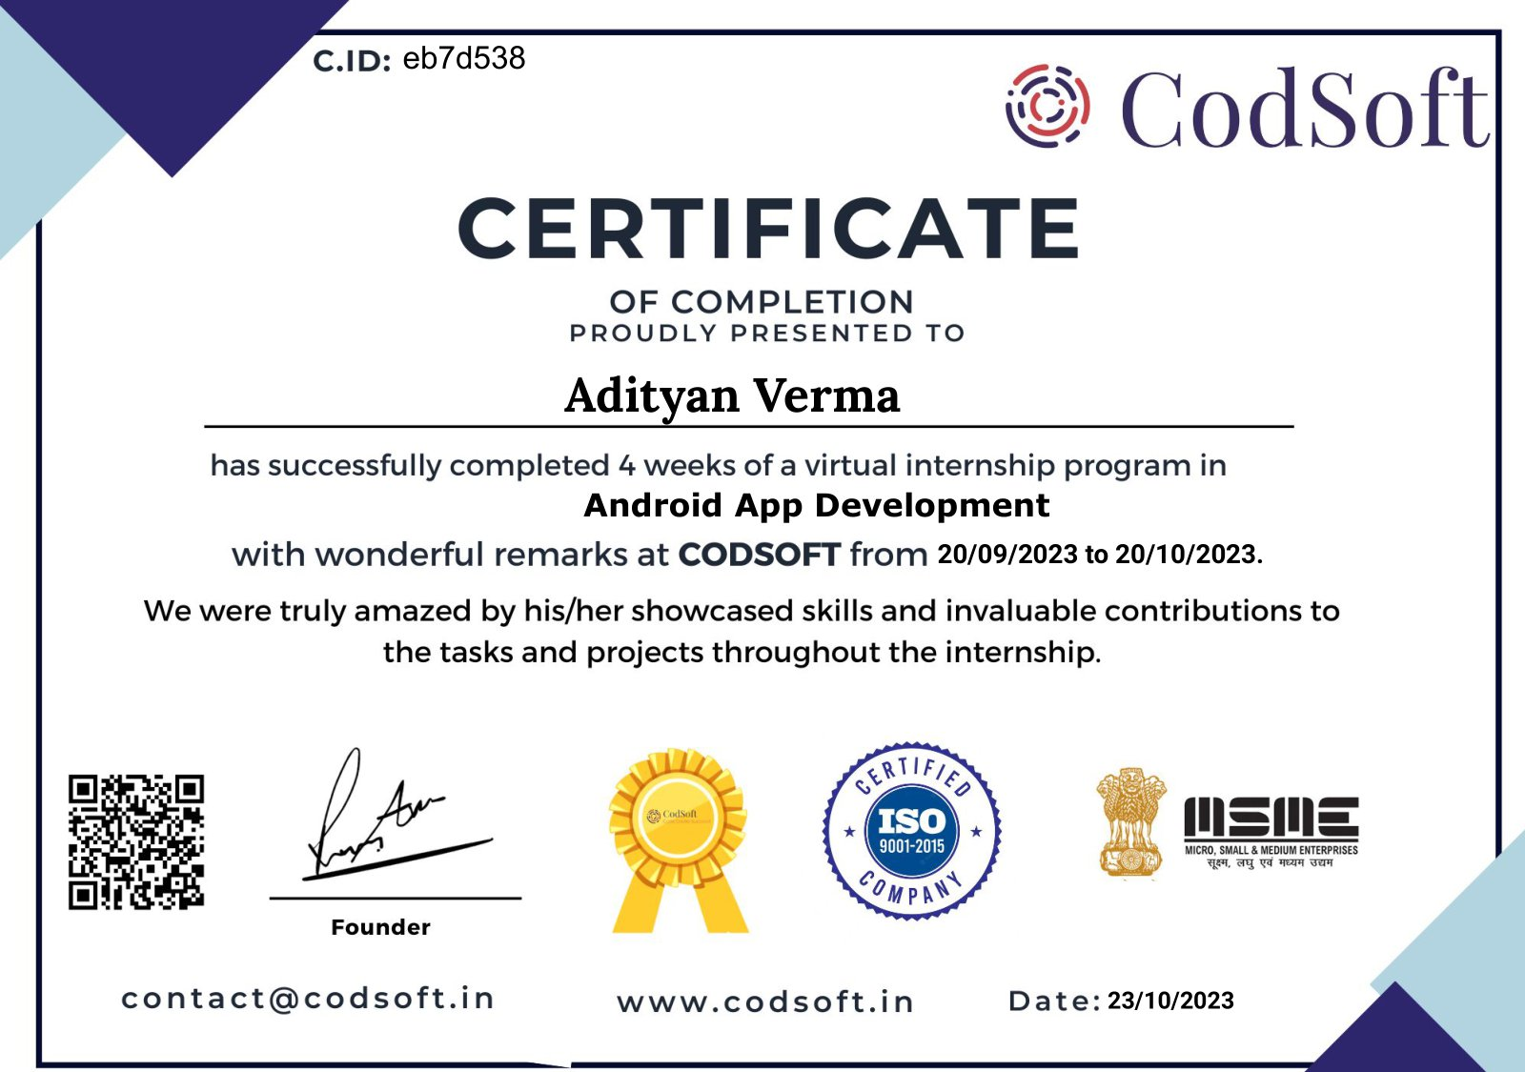

ACKNOWLEDGEMENT

Training holds immense significance in an engineering curriculum, offering practical insights into the field of study. I am delighted to announce the successful completion of my Summer Internship (Virtual) in Android App Development at CodSoft, and I'm excited to present the training report.

I extend my heartfelt gratitude to the Director for granting me this invaluable opportunity to undergo training in their esteemed organization. This experience has provided me with exposure to the intricacies of app development and a deeper understanding of mobile cybersecurity.

I would like to express my profound appreciation to CodSoft for their unwavering guidance and continuous support throughout the program. Their mentorship has greatly enhanced my skills, channeling my efforts toward a more proficient direction.

Name: Adityan Verma
Enrollment Number: 07818002721
Semester: 5th
Name: Ms. Rashmi
Designation: Assistant Professor

Signature of the Faculty

ABOUT THE COMPANY



CodSoft, a distinguished IT services and consultancy enterprise, is dedicated to pioneering innovative solutions for businesses. Driven by a deep-seated belief in the transformative potential of technology, CodSoft is unwavering in its commitment to shaping the future through cutting-edge software solutions. The company's investment in the industry's future is exemplified through its robust internship program.

At CodSoft, we recognize that practical knowledge is the linchpin for success in the dynamic tech landscape. Our internship program stands as a testament to this ethos, offering hands-on learning experiences, live projects, and real-world examples. Aimed at empowering students lacking essential skills, the program is a gateway to the practical application of theoretical knowledge.

The CodSoft team comprises industry experts passionately dedicated to equipping interns with the tools they need to thrive in their careers. We foster an inclusive and supportive environment that encourages continuous learning, personal growth, and creative thinking. Our internship initiative not only contributes to the professional development of aspiring technologists but also aligns with CodSoft's vision of being at the forefront of technological advancement, driving positive change in the IT landscape.

Website: -
http://codesoftinfotech.com/

Industry: -
IT Services and IT Consulting

ABSTRACT OF PROJECT

The To-do List Application project represents a comprehensive dive into crafting a functional and intuitive mobile application tailored for task management and productivity enhancement. This initiative aims to develop a feature-rich, user-centric app designed to organize tasks efficiently while ensuring a seamless user experience.

Built on the Android platform using Java/Kotlin and integrating various libraries and frameworks, the project prioritizes usability and performance. The application's interface is meticulously designed for ease of use, facilitating effortless navigation for users to add, manage, and track their tasks seamlessly.

Going beyond basic task management, the project incorporates interactive elements such as priority settings, deadline notifications, and task categorization, enhancing the app's utility. Additionally, it explores the integration of multimedia elements or collaborative features to elevate user engagement and functionality.

The design philosophy revolves around user accessibility and aesthetic appeal. This encompasses intuitive layouts, customizable themes, and an ergonomic design to create an engaging and memorable user experience. Moreover, the project emphasizes the app's visibility on the Android platform to maximize reach and impact.

In summary, the To-do List Application project signifies the amalgamation of mobile technology and productivity enhancement. By leveraging Android development tools and user-centric design approaches, the project aims to empower users in managing their tasks effectively, streamlining their daily routines, and leaving a lasting impression in the realm of mobile applications.

TABLE OF CONTENTS

S. No. | Title | Page No.
1 | Title page | i
2 | Certificate | ii
3 | Acknowledgement | iii
4 | About The Company | iv
5 | Abstract Of Project | v
6 | Table Of Content | vi
7 | List Of Figures | vii
8 | Chapter 1: Introduction  1.1 Introduction  1.2 Objective | 1  1  1
9 | Chapter 2: Project Overview  2.1 Project Description  2.2 Introduction and Target Audience | 2-4  2-3  4
10 | Chapter 3: Technology Used  3.1 HTML  3.2 CSS  3.3 JavaScript | 5-11  5-6  7-9  9-11
11 | Chapter 4: Project Design  4.1 Snapshots  4.2 Implementation of Code | 12-28  12-16  17-28
12 | Chapter 5: Challenges and Solutions | 29-30
13 | Chapter 6: Future and Conclusion  6.1 Future Scope  6.2 Conclusion | 31-33  31-32  33
14 | References | 34
15 | Minor Project  7.1 Problem Statement  7.2 Introduction  7.3 Abstract  7.4 Components  7.5 Snaps  7.6 Problems and Solutions  7.7 Future Scope  7.8 Conclusion | 42-45  43  43  43  43  44  45  45  45

LIST OF FIGURES

Figure No. | Figure Name | Page No.

